**DESIGN DOCUMENT**

CLASS, API’s uses in the code:

1. sock = socket(AF_INET,SOCK_DGRAM,0);

This call results in a datagram socket. The UDP protocol provides underlying communication.

1. AF_INET

Internet Family for IPV4

1. sendto

This function is used to send a message to another socket when the sockets are connected to each other

1. recvfrom:

This function is used to receive the message sent by the another socket with which it is communicating.

1. fileRead=open('123.jpg','rb')

This function will read the image in binary format.

1. fileRead.read(1024)

Reading 1024 bytes

1. fileRead.close()

Close the file which was opened.

1. fileWrite = open(outputFile, 'ab')

Opens a file for appending in binary format

1. fileWrite.seek(1024)

Start write at EOF

**SCREENSHOTS EXPLAINING THE WORKING OF CODE:**

**Server showing bind complete after first running the program and printing the acknowledgement later that “download have finished”.**

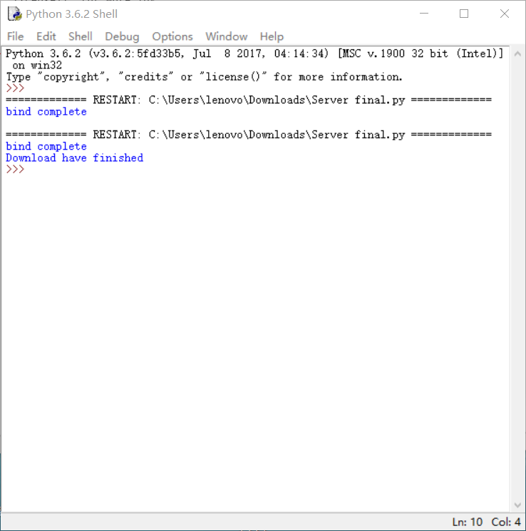

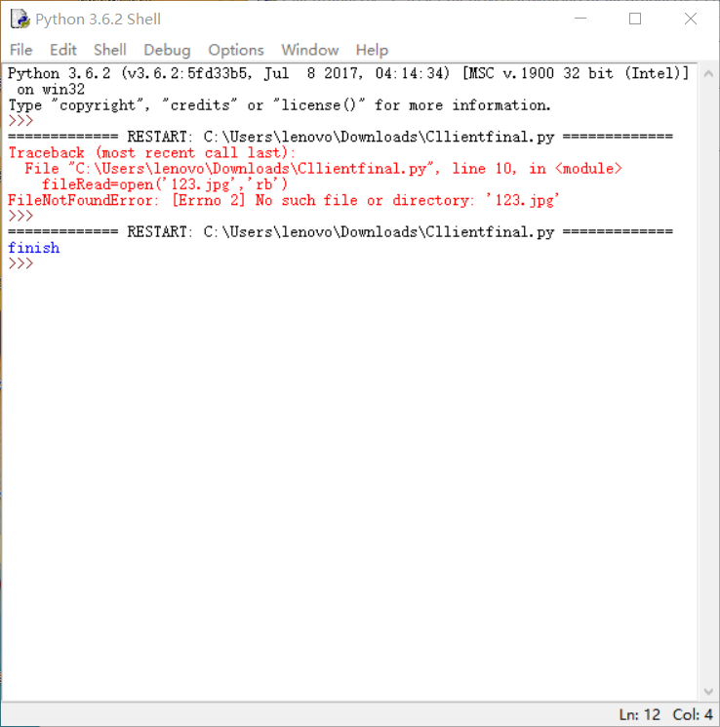**Client side screenshot shows that image has been sent and the process is complete.**